IBM Watson Machine Learning
General Discussion on Application Development

Preparing to develop the application
Bluemix makes it very easy to get a new application started. It is worth using the Bluemix Create App functionality at least once to get a good feel for what is involved.
- Go to the Bluemix web site. We’ll be using the development instance in this example, which is at https://console.stage1.ng.bluemix.net/
- Log in using your account details or sign up now for an IBM ID and access to Bluemix. It’s free.
- You may create an “org” and “space” for doing this sample development. The names used are up to you.
- Once on the dashboard for your development space, click Create App.
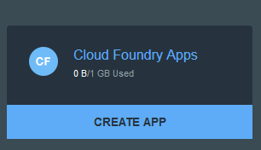
- In this example, we will create a NodeJS application. But any language capable of making REST service calls will do.
- Choose Web.
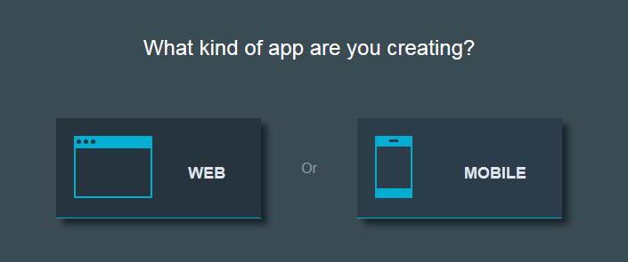
Then choose SDK for Node.js.
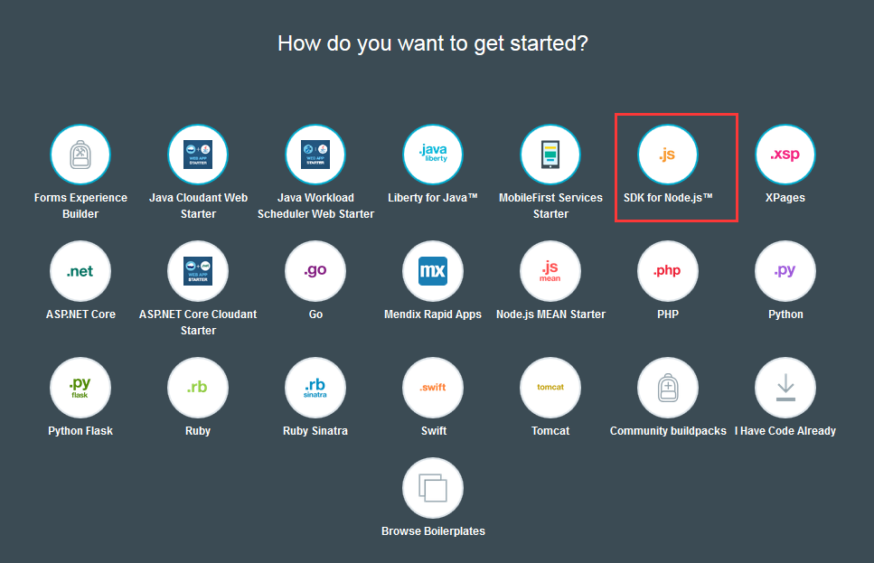
- Then your application will be created and running. It’s a simple NodeJS Starter Application. If you want more features, you can push your own NodeJS code onto this application by using one of the following methods:
a) CF Command Line Interface
b) GIT
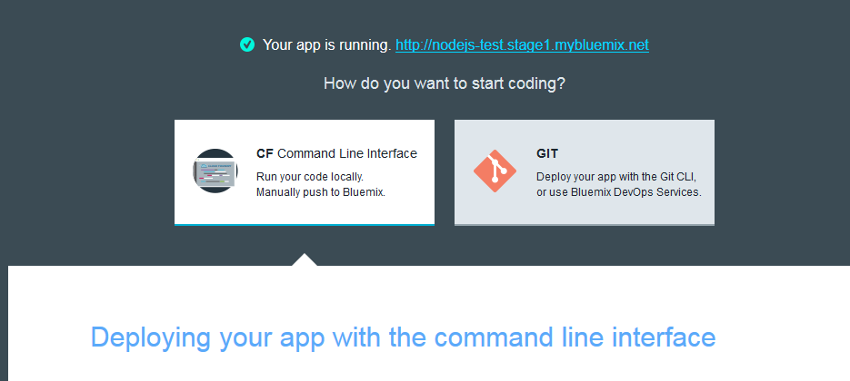
- Click the URL for the newly deployed application (beside the Your app is running) to see the welcome page. This means your application is successfully deployed.
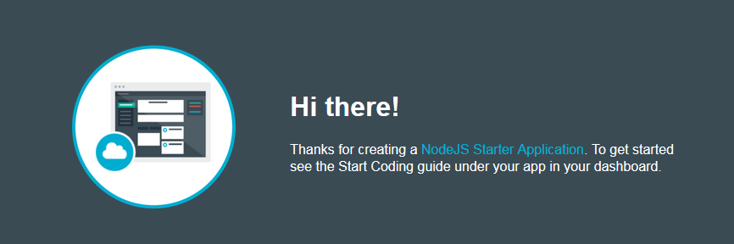
- A number of things happen when you push Create on your new application. A viable “shell” application for NodeJS is created and “pushed” out to Bluemix. The DNS routing entries that let you get to this application are entered. Then the application is started (a basic “Hello World” application). You can see the application on your dashboard.
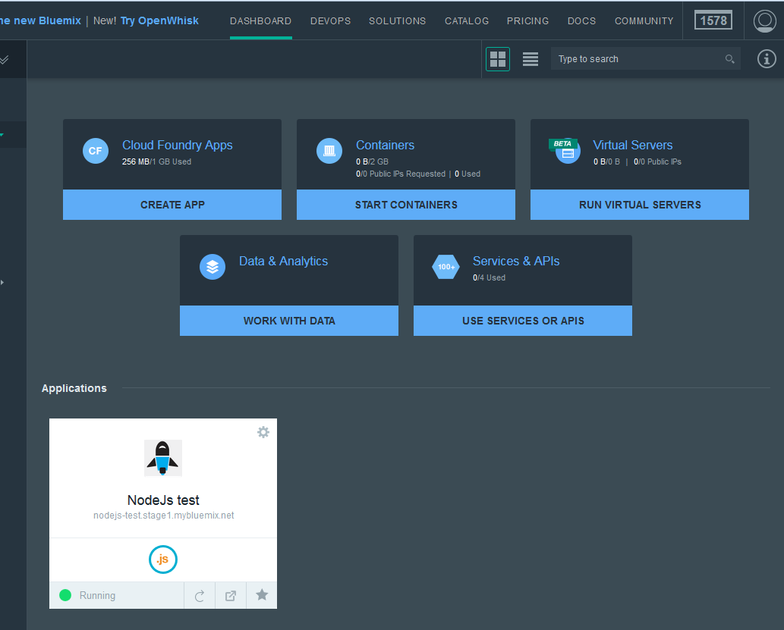

- To see more details, click the application you just deployed.
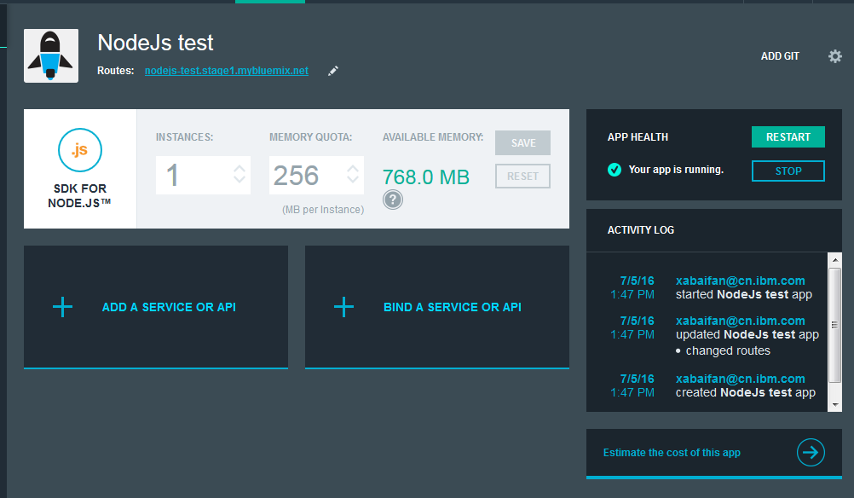
- The fun begins when you download this application and work with it on your desktop. When you select Start Coding on our application, you get help in installing the CF command line tool and downloading the sample application by clicking Download the starter code. But before you do that, install the Bluemix and CF command line interface, and add their installation directory to your Environment Variable "%Path%."
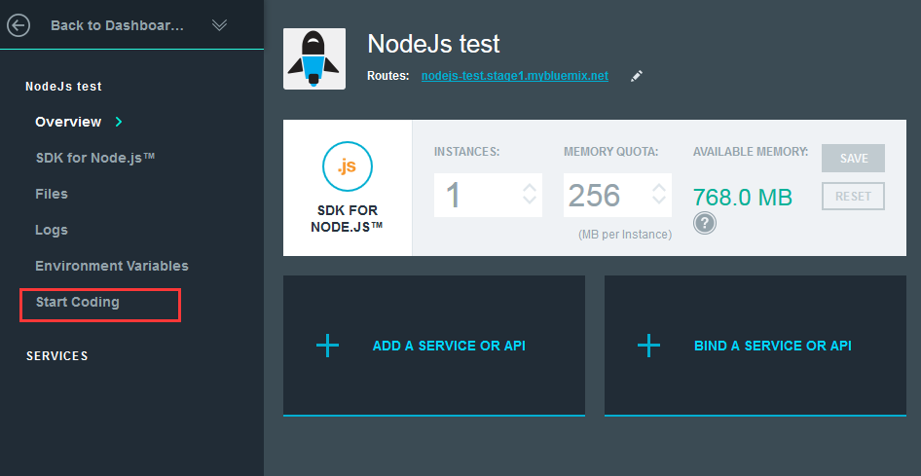

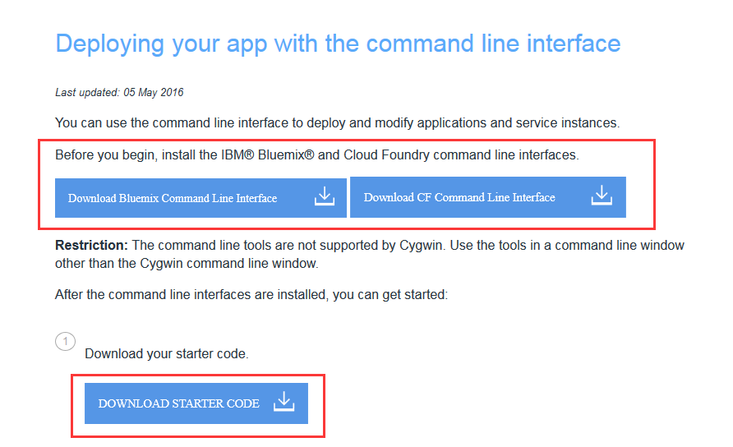
What is in this application bundle when we download it?
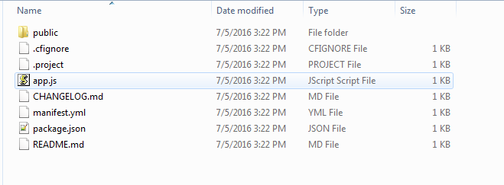
We get the basic framework for a NodeJS application (app.js and package.json) and the manifest.yml used when we push this application to Bluemix. There is also a README.txt file to help you take your next steps in building a NodeJS application.

Pushing the modified application back to Bluemix
The following comments (under the Download the starter code button described in step 11 previously) show how to push back the application after modifying it.
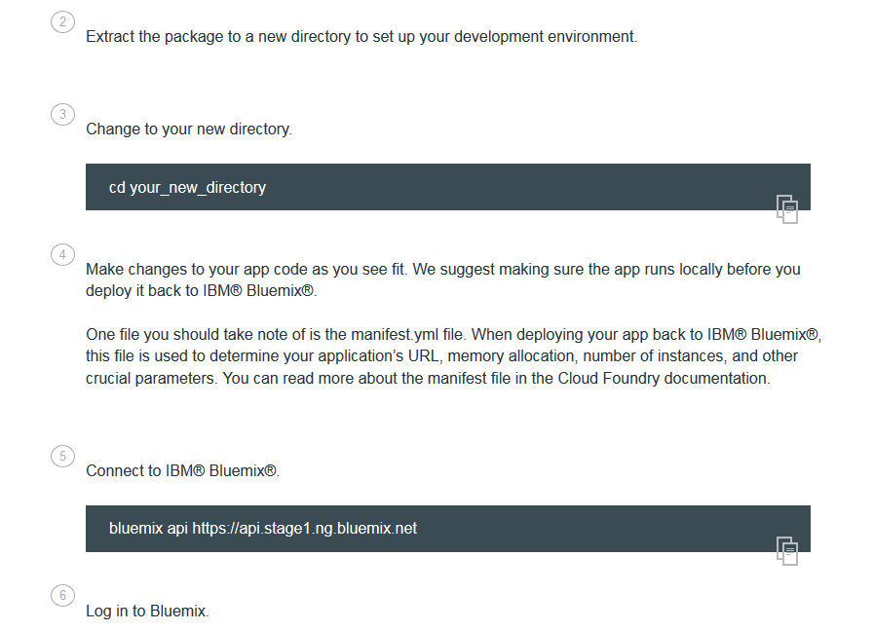
For more details, click VIEW DOCS.
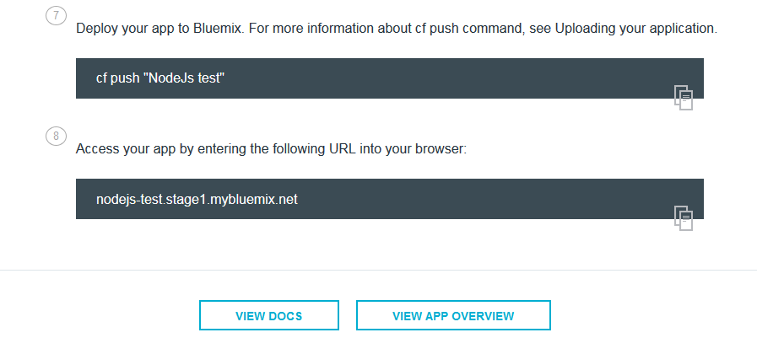
The entire bundle is transferred up to Bluemix and you will be notified as it goes through all phases of deployment and finally restarts.
Once restarted, you can launch the application from the Bluemix dashboard by clicking the Open app in a new page button.
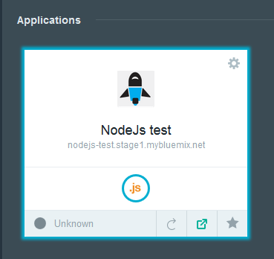

Testing your Bluemix application during development
You may provision an instance of the IBM Machine Learning service at any point in time and get the connectivity information you need to test your application from your desktop. You may also push your application back up to Bluemix at any point in time and test it there. To test your application from your desktop, you will need a compatible development environment. In the example we’ve discussed here, this would mean a NodeJS server install.
Use the ADD A SERVICE OR API or BIND A SERVICE OR API button on your Bluemix application to connect it to your service instance. ADD A SERVICE OR API adds a new service and binds it to your application. BIND A SERVICE OR API binds an existing service or API to your application.
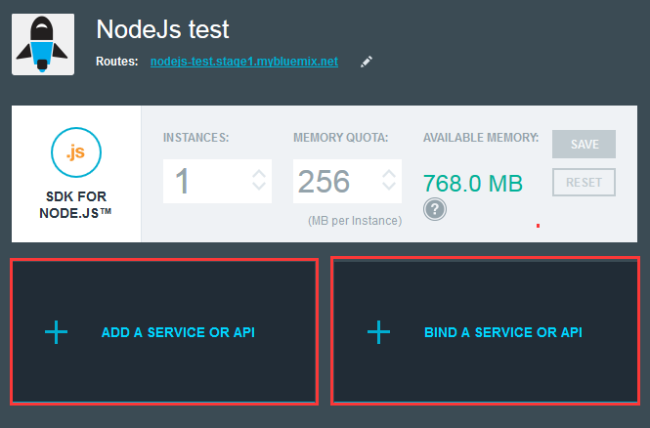
- Since this is the first time, click ADD A SERVICE OR API.
- In the Data and Analytics category, find IBM Watson Machine Learning.
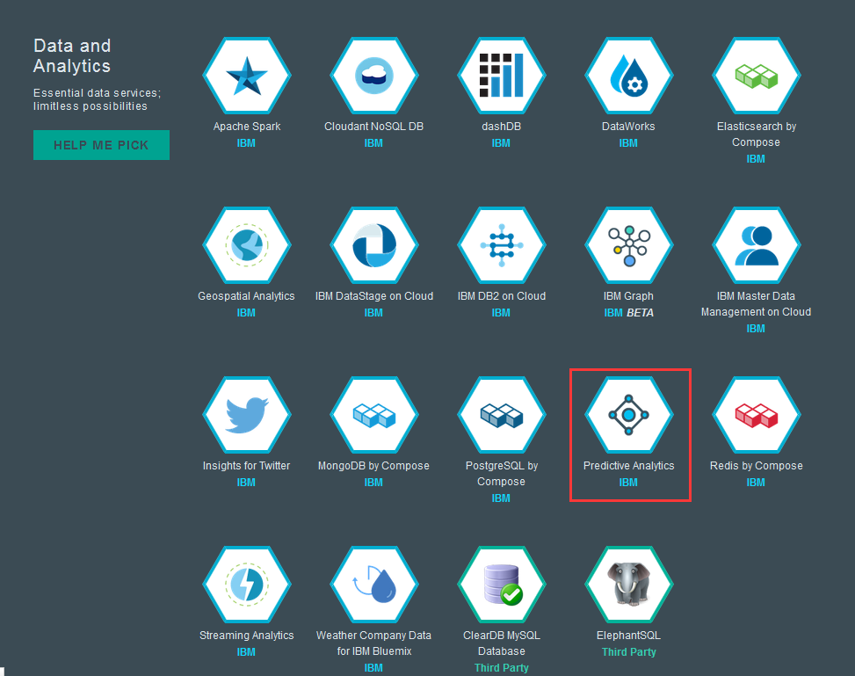
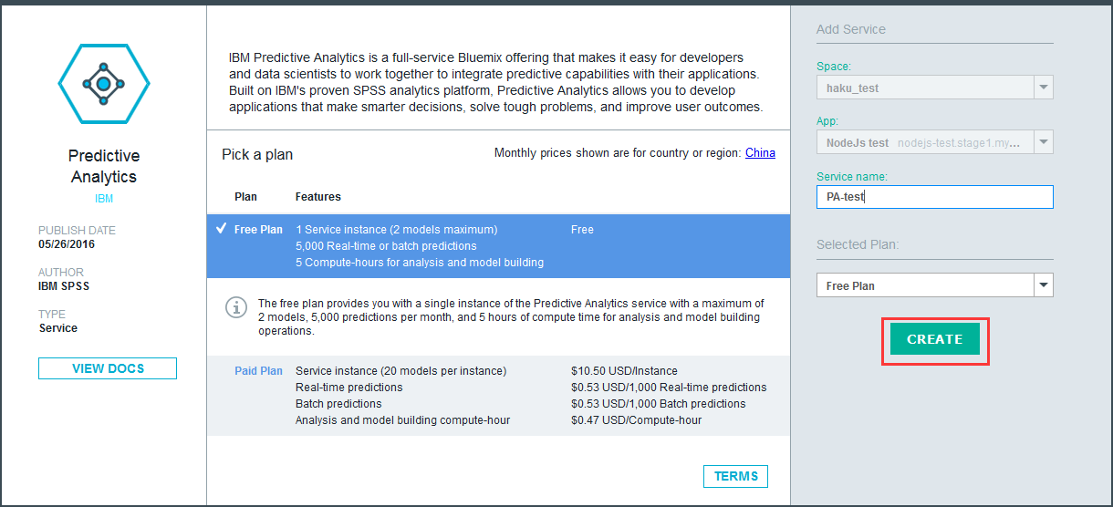

- Set your service name and fee plan, and then click CREATE. Now the service is created and bound to your application. You may click RESTAGE to restage your application and let the bound service work.
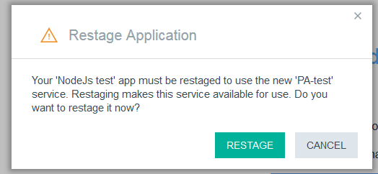
- Go to the application Overview page to see the bound service. Once the application is bound, you can click the Show Credentials button on the bound service icon to obtain the connectivity information you need to test your application from your desktop.
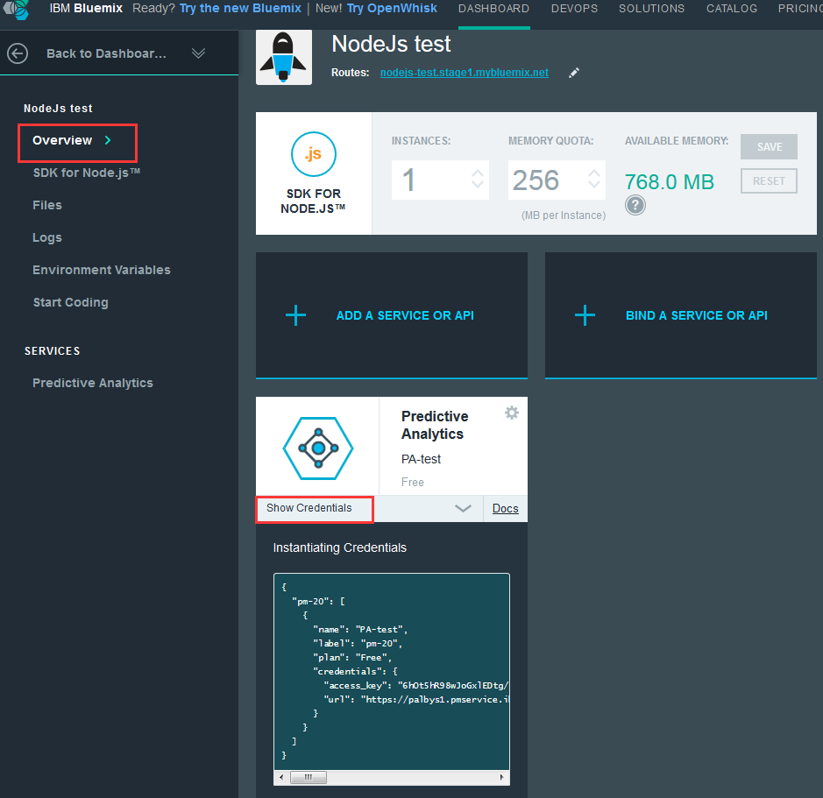
- Modify the NodeJS example app.js file to use either the Bluemix-provided environment variables VCAP_APP_HOST, VCAP_APP_PORT, and VCAP_SERVICES, or values you set to test from your desktop.
- Read the documentation in the Sample1 and Sample2 folders for information about how Sample1 and Sample2 work.

